A Review of Observations of Common Loons (Gavia immer) on Jack Lake, 1982-2016

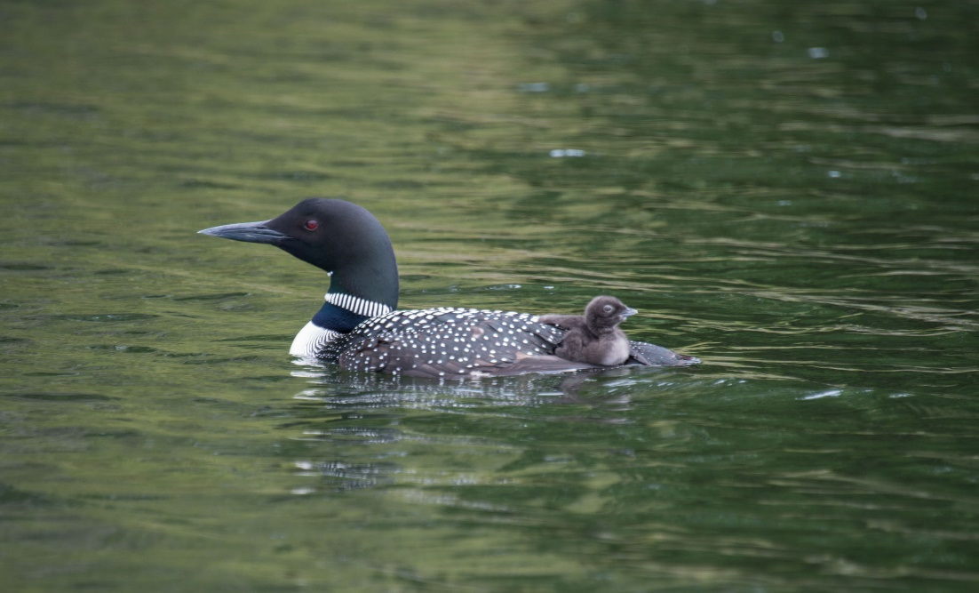

November 2016

Steven J. Kerr, Dawn Tower DuBois and Sheelagh Hysenaj
Jack Lake Association
Apsley, Ontario

Review of Observations of Common Loons (Gavia immer) on Jack Lake, 1982-2016

November 2016

Steven J. Kerr, Dawn Tower DuBois and Sheelagh Hysenaj
Jack Lake Association
Apsley, Ontario

Suggested Citation: Kerr, S. J., D. Tower DuBois and S. Hysenaj. 2016. Review of Observations of Common Loons (Gavia immer) on Jack Lake, 1982-2016. Jack Lake Association. Apsley, Ontario.
11 p. + appendices.

Cover Photo – Dawn Tower DuBois

Table of Contents

Table of Contents (i)

Introduction 1
Background 1
Characteristics of Jack Lake 1

Loon Observations 3
First Arrival 3
Nest Sites 3
Artificial Nest Rafts 4
Nesting Activities 4
Reproductive Success 5
Abandoned Nests 6
Loon Mortality 7
Fall Migration 8

Future Loon Monitoring Activities on Jack Lake 9

Acknowledgements 9

Personal Communications 9

References and Literature Cited 9

Websites 10

Appendix 1. Loon observations from Jack Lake, Peterborough County, 1982-2016.

(i)
Introduction

Background

The Canada Lakes Loon Survey (CLLS) was initiated in Ontario in 1981, and expanded nationally in 1989. It is a long term volunteer program designed to monitor the numbers and breeding success of Common Loons (Gavia immer) on lakes across Canada. When possible, volunteers conduct at least three surveys annually: (i) in June to document breeding pairs, (ii) in July to record newly hatched chicks, and (iii) in August to determine the number of offspring which have survived.

The earliest efforts of monitoring loon nesting activity on Jack Lake were initiated by the late Irene Mann, a Jack Lake cottager. Unfortunately, on a lake as large and diverse as Jack Lake, it is difficult for any one person to survey the entire lake. Between 1982 and 2012, the entire lake was surveyed on only four occasions. Since 2013, a concerted effort has been made to coordinate the efforts of a team of volunteers and conduct three lakewide surveys each year.

This report has been prepared to summarize observations of the Common Loon on Jack Lake over the past thirty-four years.

Characteristics of Jack Lake

Jack Lake is a moderately-sized (1,237 ha) headwater lake situated on the edge of the Canadian shield in southcentral Ontario approximately 200 km northeast of Toronto. The lake has a complex basin comprised of several bays connected to each other by relatively shallow channels (Figure 1). The lake has a maximum depth of 51.2 m and a mean depth of 10.0 m (Table 1).

Table 1. Selected physical and chemical characteristics of Jack Lake, Peterborough County.

Latitude | 44°41’ 20” N
Longitude | 78°02’ 54” W
Surface Area (ha) | 1,237.3
Drainage Area (km2) | 83
Maximum Depth (m) | 51.2
Mean Depth (m) | 10.0
Morphoedaphic Index (MEI) | 7.32
Water Clarity (Secchi Depth in m) | 4.9
Growing Degree Days (> 5°C) | 1,820
Flushing Rate | 0.74/year (north)  0.33/year (south)

1.
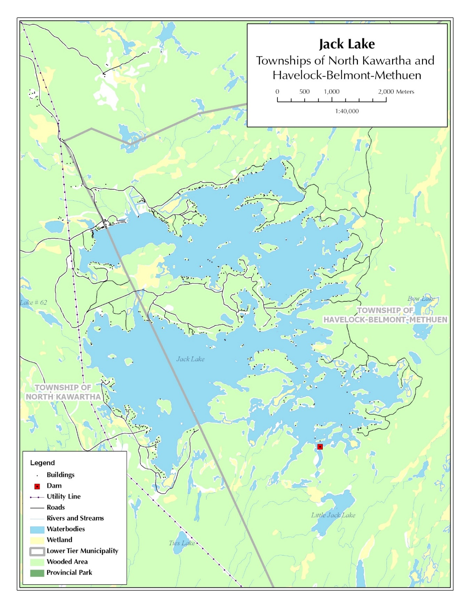
Figure 1. Jack Lake, Municipalities of North Kawartha and Havelock-Belmont-Methuen,
Peterborough County.

2.
Water levels on Jack Lake are controlled by Parks Canada to provide water for the Trent-Severn Waterway. The lake supports a diverse fish community comprised of at least twenty coldwater, coolwater and warmwater fishes (JLA Fisheries Committee 2013).

Loon Observations

First Arrival

Loons usually arrive back in Jack lake during late April often coincident with ice-out. The earliest arrival recorded on Jack Lake occurred in 2010 when a single adult was observed in Williams Bay on April 4 (Sheelagh Hysenaj personal observation). In 2014, approximately 20 adult loons were sighted on open water of the Narrows on April 19 (Ashleigh Johnston personal communication).

Nest Sites

The male loon selects the nest site. Both parents construct the nest in late May or early June. Nest sites are usually situated in in quiet protected areas such as the lee of an island or the end of a secluded bay. Nest construction can take several days. The nest is often comprised of reeds and marsh grasses which are shaped to match the contours of the loon’s body. Since loons are very clumsy on land, nest sites are situated close to the waters edge often adjacent to deeper water so that the bird can approach the nest from underwater.

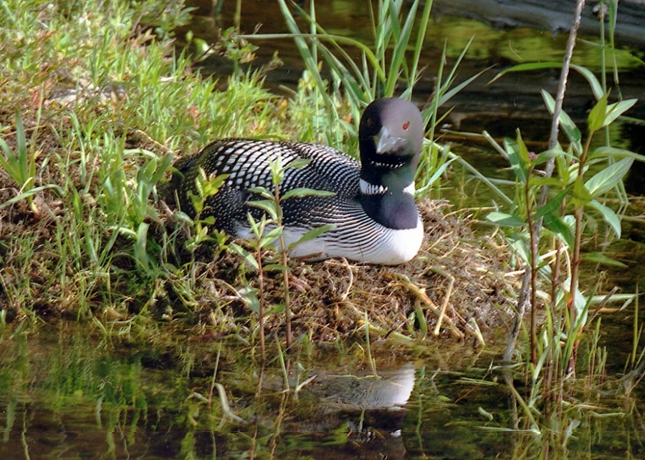

Figure 2. Nesting loon on Jack Lake (Dawn Tower DuBois photo).

3.
Over the past 10-15 years, loon nests on Jack Lake have most commonly been documented in Brooks Bay, Sheeps Bay, Center Bay, Williams Bay and McCoy Bay. Observations have indicated that the actual site of the nest in these bays can vary from year to year.

Artificial Nest Rafts

In an effort to provide additional nesting habitat which would reduce the impact of predation and water level fluctuations, four artificial nest rafts were constructed and deployed in 2015. Artificial rafts were constructed based on available guidelines (DeSorbo et al. 2008, Bird Studies Canada undated).

These four artificial nest rafts were constructed in September, 2014 (Figure 3). In the spring of 2015 the nest rafts were deployed at the end of Redmond Bay, East Bay and Long Bay as well as a site near the outlet dam. None of the rafts were utilized by loons during the 2015 season. The rafts were pulled ashore in the fall of 2015 and all but the Redmond Bay raft were deployed for the 2016 season (same sites). None of the rafts were utilized during the 2016 season.

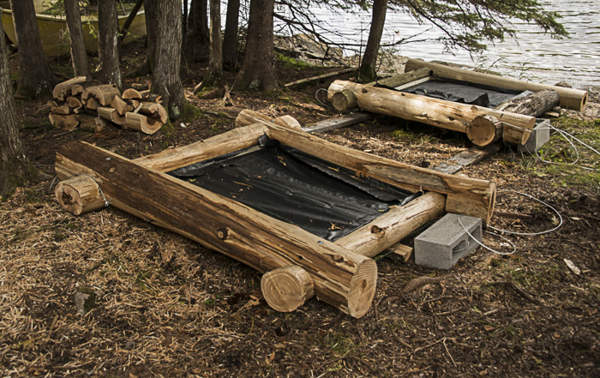

Figure 3. Artificial loon nest rafts constructed on Jack Lake (Dawn Tower DuBois photo).

Nesting Activities

The clutch size for a Common Loon is commonly 1-2 eggs. Both parents are involved with incubation. The incubation period typically ranges from 26-29 days. On Jack Lake, nesting

4.
activity (i.e., observations of loons incubating eggs on their nest) has ranged from May 27 (2016) to June 22 (2013). Hatching dates for young-of-year (YOY) loons has ranged from June 25 to August 1 (Table 2).

Table 2. Loon hatching dates documented on Jack Lake, 2007-2016.

Year | Date YOY Loons First Observed | Location
2007 | June 24 | Sheeps Bay
2008 | June 27 | Center Bay
 | June 28 | Sheeps Bay
2009 | July 5 | Brooks Bay
2010 | June 20 | Center Bay
 | July 2 | Williams Bay
2011 | June 24 | Brooks Bay
 | June 25 | Callahan Bay
 | July 3 | Williams Bay
2012 | July 2 | Williams Bay
 | July 4 | Callahan Bay
2013 | June 30 | Sheeps Bay
 | July 1 | Sharpe’s Bay
 | July 29 | Brooks Bay
2014 | June 28 | Brooks Bay and Callahan Bay
 | August 1 | Center Bay
2015 | June 29 | Sheeps Bay
 | July 1 | Center Bay
 | July 2 | Williams Bay
2016 | June 25 | Brooks Bay
 | July 2 | Williams Bay

The two latest hatch dates which were recorded occurred on July 29, 2013 and August 1, 2014. It is believed that these were both the result of second nesting attempts.

Reproductive Success

Lakes in eastern Canada are known to have lower reproductive success for Common Loons than elsewhere (Tozer et al. 2013). The number of nesting pairs of loons on Jack Lake has varied from 1 - 10 (mean 3.4 breeding pairs). The number of chicks which survived to their first fall ranged from 0 - 5 (mean 2.6 chicks). This low level of recruitment is a primary reason why loons are declining in Canada (Figure 4) particularly the eastern portion of the country.

5.

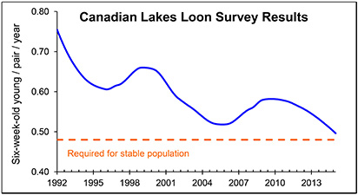

Figure 4. Surviving chicks per breeding pair of Common Loons in Canada based on results
of the Canada Lakes Loon Survey (Tozer et al. 2013).

Abandoned Nests

There have been several documented instances of nest abandonment on Jack Lake.

In 2015, a nest containing one egg was abandoned in southwestern Sharpe’s Bay (Figure 5). The egg was eventually collected and forwarded to Carleton University, Ottawa, for contaminant analysis. It is unknown why the nest was abandoned.

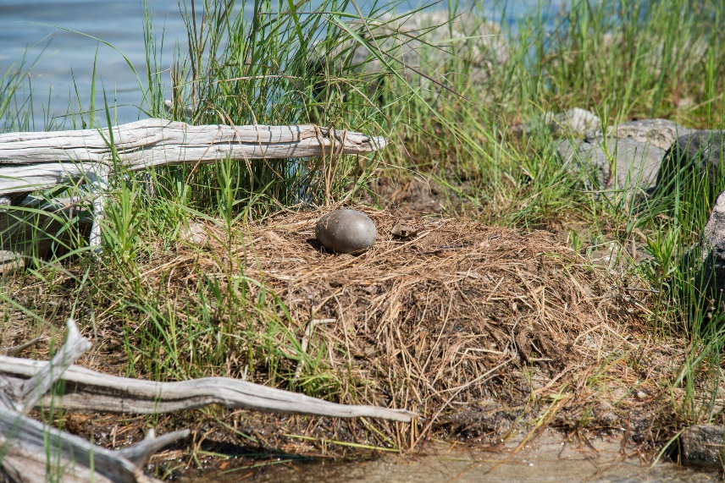

Figure 5. Abandoned loon nest in Shape’s Bay, 2015 (Dawn Tower DuBois photo).

6.
In 2016 one nesting loon abandoned its nest in Center Bay. This was attributed to human camping (with a dog) activities on the small island. Another nest in the southwest portion of Sharpe’s Bay was also apparently abandoned in 2016 (Russell Miller, personal communication). The reason for abandonment was unknown.

A 2016 loon nest in Brooks Bay originally contained two eggs but the second egg was abandoned after the first chick hatched (Figure 6) (Shellagh Hysenaj personal observation).

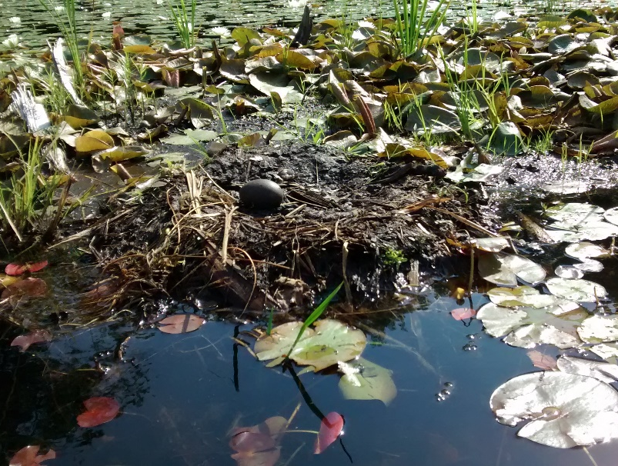

Figure 6. Second egg abandoned at loon nest in Brooks Bay in 2016 (Sheelagh Hysenaj photo).

Loon Mortality

There are numerous causes of loon mortality. These can include nest predation, water level fluctuations, impacts of recreational boaters, water quality, prey availability, lead poisoning and increases in mercury concentration in food sources (Fimreite 1974, Alvo et al. 1988, Wayland and McNicol 1990, Merrill et al. 2005).

Water level fluctuations have had adverse effects on loon nesting in the past. Jack Lake has its water level artificially controlled by the Trent-Severn Waterway (TSW). There have been several instances of fluctuating water levels during the nesting period which extends from late May-July. In 1986, a petition, signed by more than 280 lake residents, requesting stable water levels during the loon nesting period was forwarded to Parks Canada.

Several dead loons have been found in Jack Lake over the years (Table 3). Of three loon mortalities in 1993, two were killed by boats as evidenced by cuts on their bodies. The third

7.
had apparently choked to death on a fish that had become lodged in its throat due to a fishing lure caught in the bird’s beak (Irene Mann, unpublished records). In that same year, there were six young loons that hatched but only four survived until the fall.

Table 3. Documented loon mortality on Jack Lake, 1982-2016.

Year | No Dead Loons Documented | Location
1989 | 1 | Unrecorded
1991 | 1 | Narrows
1993 | 3 | Unrecorded
2011 | 1 | Center Bay

Fall Migration

Loons are migratory birds which fly south to spend the winter. Migrations occur in three stages: non-breeding birds are the first to leave followed by breeding pairs. Young-of-the-year loons are left on their own to eventually form into small flocks with other juvenile birds and head south a few weeks later.

Social flocking starts to occur in mid to late summer (Table 4).

Table 4. Recent observations of social flocking by loons on Jack Lake.

Date | Flocking Observations | Observer(s)
July 13, 2007 | Congregation of five adult loons in Rathbun Bay | Steven Kerr
July 15, 2008 | Congregation of five adult loons in Rathbun Bay | Steven Kerr
October 9, 2011 | Three adult loons on Sharpe’s Bay | Sheelagh Hysenaj
July 26, 2013 | Five adult loons at Hurricane Point | Susan Quarry
July 18, 2015 | Four adult loons together in Brooks Bay | Steven Kerr
July 19, 2015 | Four adult loons congregated in Robbins Bay | Steven Kerr
July 9. 2016 | Congregation of five adult loons in Brooks Bay | Janis Tripp
July 19, 2016 | Four adult loons in Rathbun Bay | Steven and Karen Kerr
July 28, 2016 | Four adult loons in Williams Bay | Steven Kerr
August 8, 2016 | Six adult loons at the Narrows | Wendy Hutchinson

On Jack Lake parent loons are usually observed with their young until the first week or two in October when they depart. Young-of-year loons are typically the last to leave (Table 5).

8.
Table 5. Fall observations of young-of-year loons on Jack Lake.

Date | Observation
October 8, 2007 | Single young-of-year observed in Center Bay
October 2, 2010 | Single young-of-year loon observed.
October 5, 2013 | One adult with two young-of-year loons in Callahan Bay
October 12, 2013 | Single young-of-loon observed in Center Bay
October 25-26, 2014 | Four young-of-year loons observed
October 18, 2015 | One young-of-year in Center Bay

Future Loon Monitoring Activities on Jack Lake

The Common Loon is an incredibly special bird to most Jack Lake residents, cottagers and visitors. We hope to continue volunteer efforts in the future to monitor the status of loons on our lake. Our efforts will be concentrated on maintaining lakewide counts (supplemented by individual observations) as well as encouraging more volunteers to report their sightings on the lake. Information derived from future surveys will freely shared with government management agencies, the Canada Lakes Loon Survey, local naturalist clubs and interested individuals.

Acknowledgements

We gratefully acknowledge the efforts of many volunteers in recent years. These include (listed alphabetically by surname): Mary Beadon, Charlie Coffey, Bill DuBois, Bob and Marcine DuBois, Shari Fulmer, Sheelagh Hysenaj, Kevin Irwin, Ashleigh Johnston, Bill Johnston, Allan, Steven and Karen Kerr, Neill Lanz, Alan Long, Irene Mann, Doug and Eileen Moulton, Jim and Jean Perun, Alan and Susan Quarry, Guy and Eunice Speed, Dawn Tower-DuBois, Arnold and Janis Tripp, Pat and Victor Ward and Alice Wynter. Artificial nest rafts were constructed by Jim Perun, Bill DuBois, Bob DuBois and Bill Pezzack.

Personal Communications

Johnston, Ashleigh, Jack Lake seasonal resident
Jones, Kathy, Bird Studies Canada, Long Point
Miller, Russell. Jack Lake seasonal resident.

References and Literature Cited

Alvo, R., D. J T. Hussell, and M. Berrill. 1988. The breeding success of common loons (Gavia immer) in relation to alkalinity and other lake characteristics in Ontario. Canadian Journal of Zoology 66:746–752.
9.

Bird Studies Canada. Undated. Instructions on building an artificial nesting platform for loons. Port Rowan, Ontario. 5 p.

Canada Lakes Loon Survey and Bird Studies Canada. Undated. Loon friendly lakes – Tips for boaters, cottagers and other lovers of lakes and loons. Pamphlet. Port rowan, Ontario.

Canadian Wildlife Service. 1990. Loons. Hinterland Who’s Who. Environment Canada. Ottawa,
Ontario. 4 p.

DeSorbo, C. R., J. Fair, K. Taylor, W. Hanson, D. C. Evers, H. S. Vogel and J. H. Cooley. 2008. Guidelines for constructing and deploying common loon nesting rafts. Northeastern Naturalist 15:75-86.

Fimreite, N. 1974. Mercury contamination of aquatic birds in northwestern Ontario. Journal of Wildlife Management 38:120–131.

Jack Lake Fisheries Committee. 2013. A review of fisheries management activities on Jack Lake and proposals for the future. Jack Lake Association. Apsley, Ontario. 27 p. + appendices.

Kerr, S. J. 2007. Loons. p. 31-32 In Smoke Signals. Jack Lake Association. Apsley, Ontario.

McNicol, D. K., M. L. Mallory and H. S. Vogel. Using volunteers to monitor the effects of acid precipitation on common loon (Gavia immer) reproduction in Canada: The Canada Lakes
Loon Survey. Journal of Water, Air and Soil Poollution 85:463-468.

Merrill, E. H., J. J. Hartigan and M. W. Meyer. 2005. Does prey biomass or mercury exposure affect loon chick survival in Wisconsin? Journal of Wildlife Management 69:57-67.

Tozer, D. C., C. M. Falconer, and D. S. Badzinski. 2013. The Canadian Lakes Loon Survey 1981-2012: 32 years of monitoring Common Loons as indicators of ecosystem health. Published by Bird Studies Canada. Port Rowan, Ontario. 14 pp

Wayland, M. and D. McNicol. 1990. Status report on the effects of acid precipitation on common loon reproduction in Ontario: The Ontario lakes loon survey. Technical Report Series 92. Canadian Wildlife Service, Ontario Region, Canada.

Websites

https://www.allaboutbirds.org/guide/common_loon/lifehistory

http://bna.birds.cornell.edu/bna/species/313/articles/introduction#_ga=1.168447975.710982580.1470763193

10.

http://www.audubon.org/field-guide/bird/common-loon

http://www.hww.ca/en/wildlife/birds/loon.html?referrer=https://www.google.ca/

http://www.sbaa.ca/projects.asp?cn=303

http://bsc-eoc.org/index.jsp?lang=EN Bird Studies Canada

11.
Appendix 1. Loon observations from Jack Lake, Peterborough County, 1982-2016.

Year | % of Lake Surveyed | Number of Breeding Pairs | Number of Large Young-of-Year
1982 | 55% | 5 | 1
1983 | Unknown | 8 | 3
1984 | 0% | Unknown | Unknown
1985 | 0% | Unknown | Unknown
1986 | 25% | 5 | 4
1987 | 10% | 1 | 1
1988 | 100% | 1 | 0
1989 | 80% | 2 | 2
1990 | 100% | 10 | 0
1991 | 10% | 1 | 2
1992 | 100% | 1 | 0
1993 | 100% | Unknown | 4
1994 | 20% | 4 | 5
1995 | 40% | 4 | 4
1996 | 55% | 4 | 3
1997 | 37% | Unknown | 1
1998 | 15% | Unknown | 3
1999 | 60% | Unknown | 5
2000 | 20% | Unknown | 3
2001 | 25% | 2 | 3
2002 | 25% | 2 | 3
2003 | 30% | 2 | 3
2004 | 0% | Unknown | Unknown
2005 | 10% | 1 | Unknown
2006 | 30% | 2 | Unknown
2007 | 60% | 3 | Unknown
2008 | 40% | 3 | 3
2009 | 60% | 3 | 1
2010 | 40% | 2 | 2
2011 | 40% | 4 | 2
2012 | 40% | 3 | 3
2013 | 100% | 5 | 3
2014 | 100% | 3 | 4
2015 | 100% | 6 | 4
2016 | 100% | 4 | 4
Summary | 0 – 100%  (Mean = 47.9%) | 1 – 10  (Mean = 3.4) | 0 – 5  (Mean = 2.6)

